Test Case: tc001_SPX_Dev5_Crear_Requisicion_Spot_Tipo_Cobro_CC
Step 1 - Enter username and password and click to button Enter : Credentials Entered
Image file-name: QC_Testing-tc001_SPX_Dev5_Crear_Requisicion_Spot_Tipo_Cobro_CC-1788297365301

Step 2 - Select to UEN and Access to Spot Buy Requisitions : UEN Correctly selected and Correct access
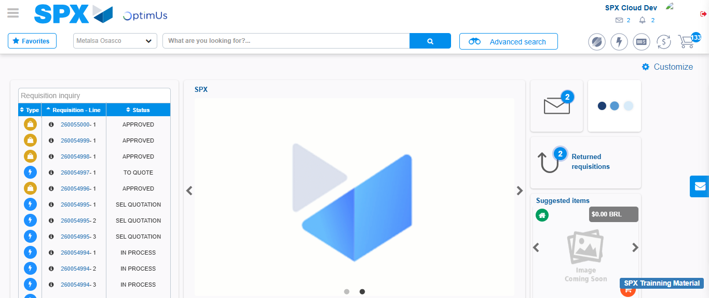Image file-name: QC_Testing-tc001_SPX_Dev5_Crear_Requisicion_Spot_Tipo_Cobro_CC-1788297391634

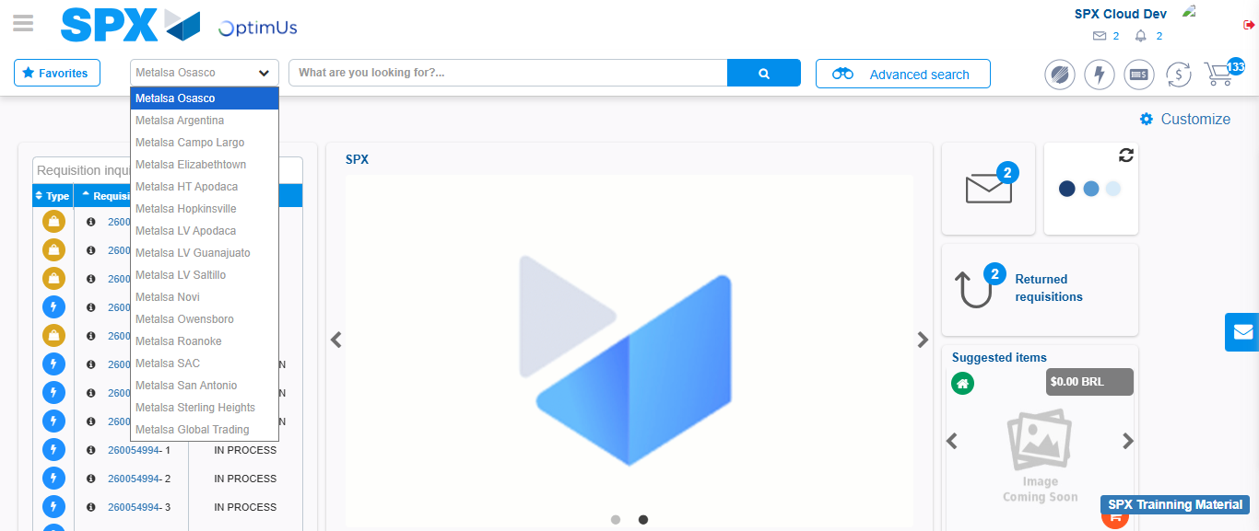Image file-name: QC_Testing-tc001_SPX_Dev5_Crear_Requisicion_Spot_Tipo_Cobro_CC-1788297392282

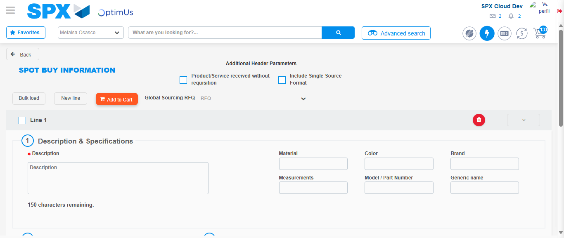Image file-name: QC_Testing-tc001_SPX_Dev5_Crear_Requisicion_Spot_Tipo_Cobro_CC-1788297422863

Step 3 - Data Capture Spot Buy Requisition : Data captured correctly
Image file-name: QC_Testing-tc001_SPX_Dev5_Crear_Requisicion_Spot_Tipo_Cobro_CC-1788297423149

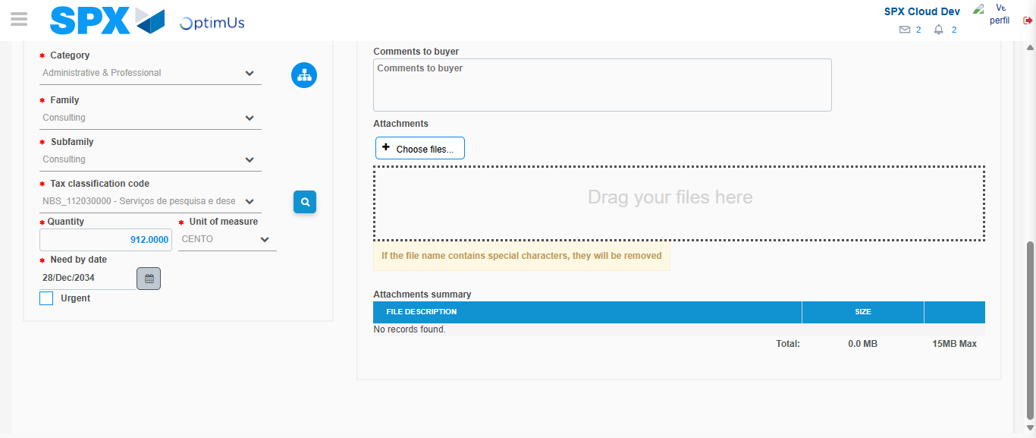Image file-name: QC_Testing-tc001_SPX_Dev5_Crear_Requisicion_Spot_Tipo_Cobro_CC-1788297439687

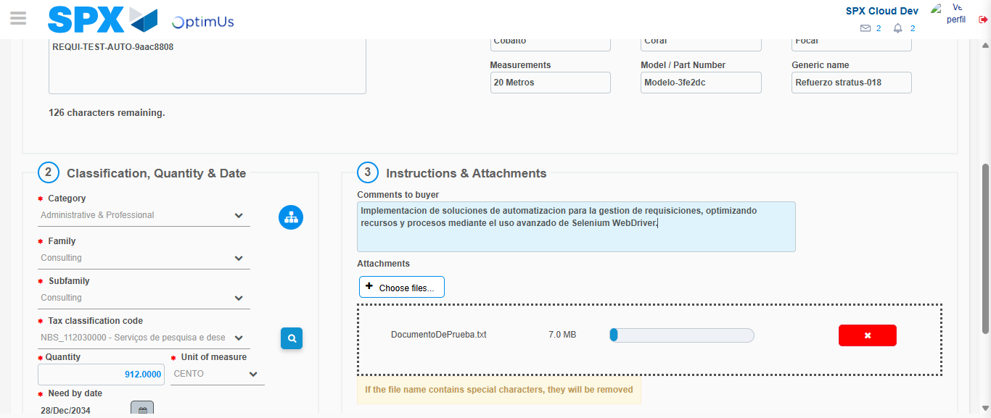Image file-name: QC_Testing-tc001_SPX_Dev5_Crear_Requisicion_Spot_Tipo_Cobro_CC-1788297440519

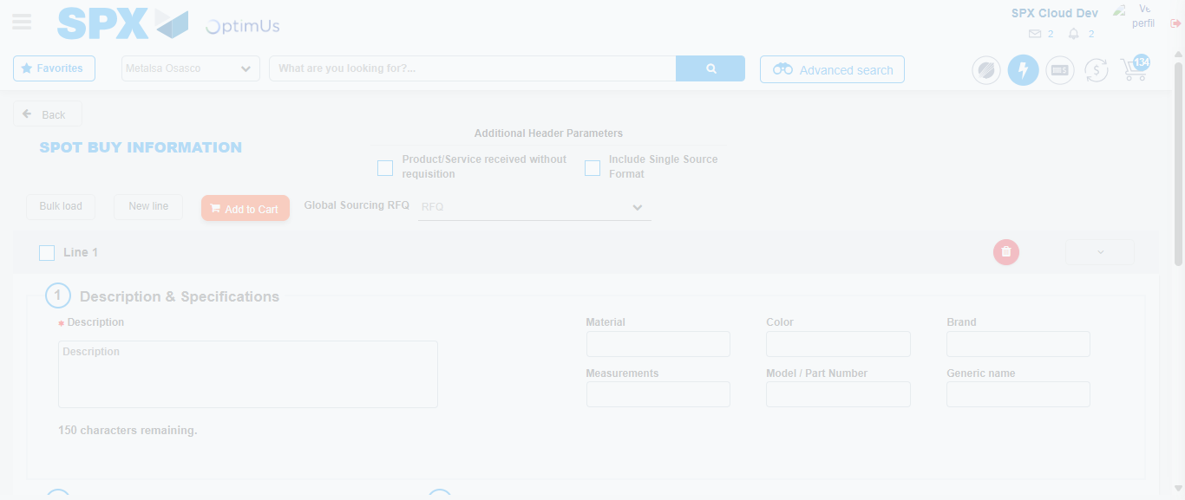Image file-name: QC_Testing-tc001_SPX_Dev5_Crear_Requisicion_Spot_Tipo_Cobro_CC-1788297446185

Step 7 - Return to Main Page SPX : Return to Main Page SPX
Image file-name: QC_Testing-tc001_SPX_Dev5_Crear_Requisicion_Spot_Tipo_Cobro_CC-1788297391634

Image file-name: QC_Testing-tc001_SPX_Dev5_Crear_Requisicion_Spot_Tipo_Cobro_CC-1788297392282

Image file-name: QC_Testing-tc001_SPX_Dev5_Crear_Requisicion_Spot_Tipo_Cobro_CC-1788297422863

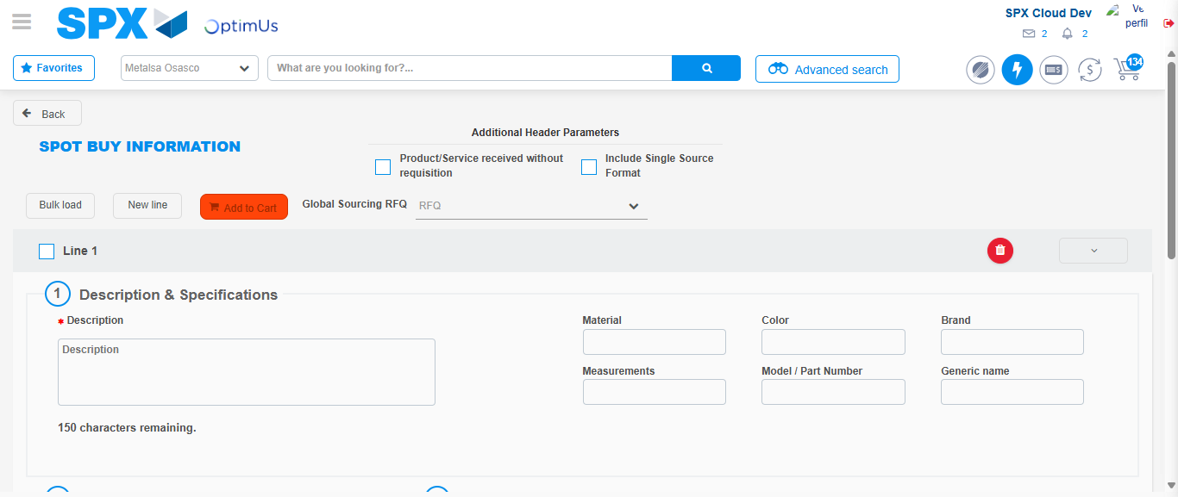Image file-name: QC_Testing-tc001_SPX_Dev5_Crear_Requisicion_Spot_Tipo_Cobro_CC-1788297448484

Image file-name: QC_Testing-tc001_SPX_Dev5_Crear_Requisicion_Spot_Tipo_Cobro_CC-1788297448728

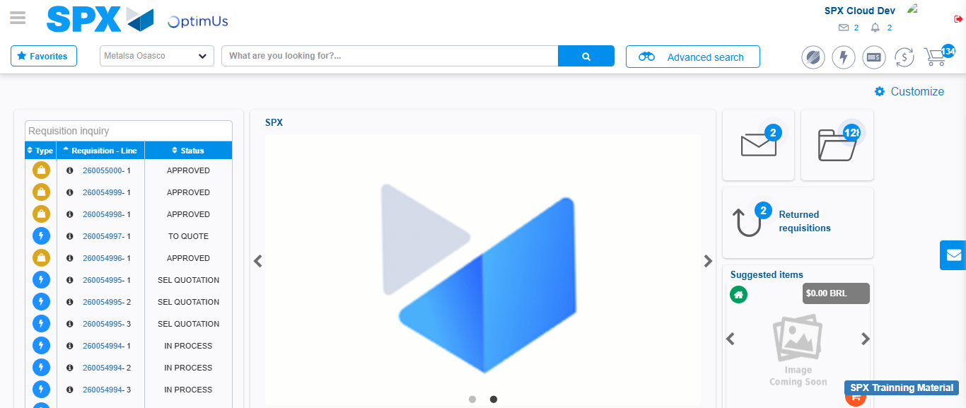Image file-name: QC_Testing-tc001_SPX_Dev5_Crear_Requisicion_Spot_Tipo_Cobro_CC-1788297469934

Step 8 - Log Out : Log Out SPX
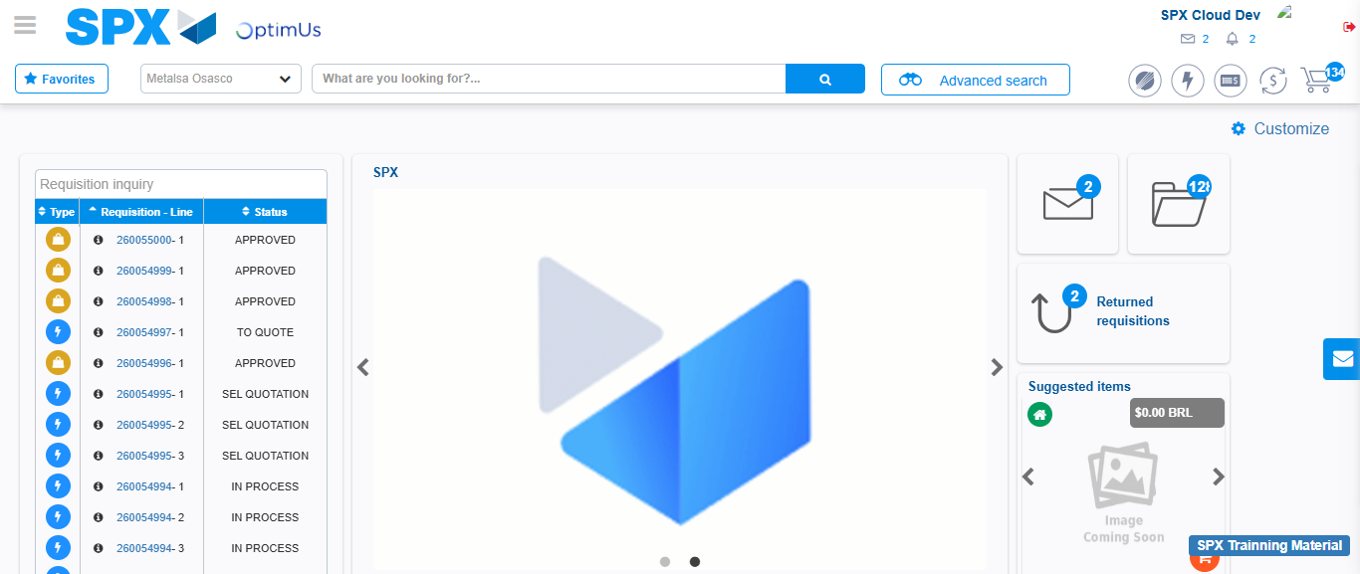Image file-name: QC_Testing-tc001_SPX_Dev5_Crear_Requisicion_Spot_Tipo_Cobro_CC-1788297470298

